1. 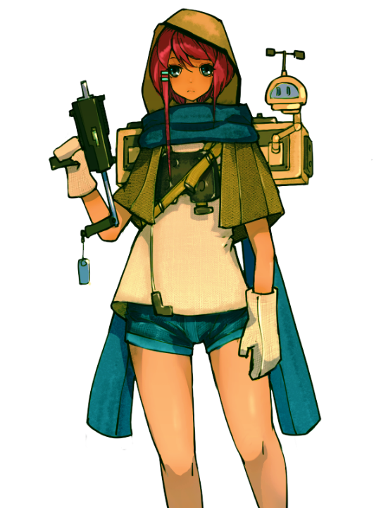ROLE：

**Wandering girl**

**Illustrated text:**

The wandering girl, whose identity is a mystery, who is obviously a wanderer but has high-tech equipment, constantly walking through the ruins of the city, seems to be wary of something.

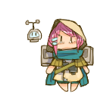Note: Very hostile to the sudden appearance of me, but after realizing that it was a human being, she quickly stopped guard. She was a nagging guy, but she never mentioned her name. What a strange person.

*a. First encounter, located in the room of the second scene: in the abandoned toilet (A is npc, B is the protagonist)*

A: Who is it? ! ! !

B: Oh oh oh! calm down! I have no hostility!

A: Ah, sorry! (She puts away the weapon in a panic) So you are a human, and I thought it was those damn bugs again.

B: Phew, you scared me, I'm not a bad person.

A: It's very unsafe near here. You see, insect eggs are everywhere, but fortunately, the ones here are already dead.

B: Oh, that's really disgusting. Are you also a scavenger?

A: I... Uh, maybe? Why did you come here? It's very dangerous. It's not the place where the little girl should come. How about your...your family?

B: My father is gone...I want to find him. He said that he had gone to Grey Hill and told me not to look for him. This is crazy. How could he left his daughter like this!

A: (Suddenly panicked) Don't go to Grey Hill! ! Uh, I mean you should listen to your father, maybe he will be back soon, right?

B: No, I have a lot of questions to ask, I must find him! (Gets up and leaves)

A: Any... Anyway, don't go to Ash Mountain!

*b****. Encountered for the second time,*** *at the end of the forest (unfinished scene)*

A: Who! ? Phew, it's you again, you're still here... (she panted, it seems that she's having a bad time this time)

B: Uh, Miss Wanderer, you look terrible.

A: It's okay, it's just bitten by a bug.

A: But, unbelievable that you really walk through this damn forest！ You still want to find your dad？

B: Sorry, Miss Wanderer, I must come. I have to find my dad.

A: It's fine... if I can't persuade you, but I have to tell you that the road ahead is not easy...

B: (Leaves some medicine, gets up) Since I have come here, there is no reason to look back.

A: You are really... (softly) as stubborn as him...

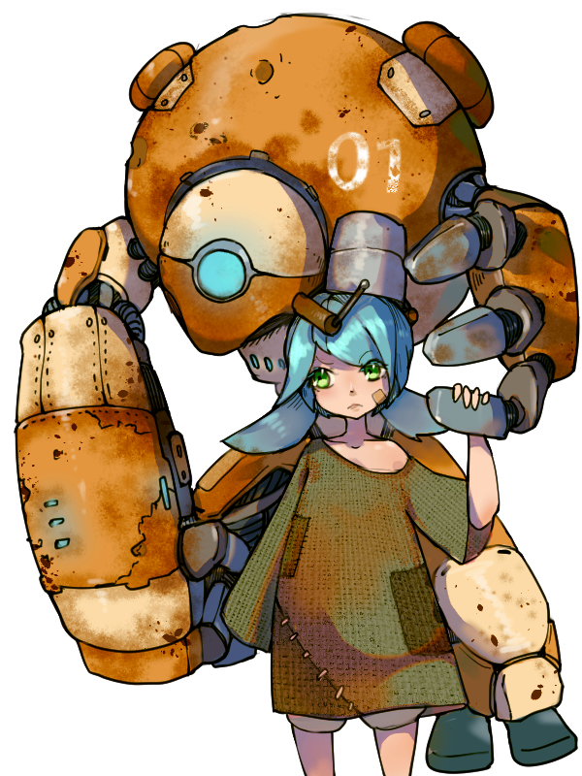**Anatacia**

**Illustrated text:**

The little girl who lives in an abandoned garbage dump has a giant robot partner named "Little Bear". It seems that she has never seen her parents and regards the garbage dump as his home, while the robot is her "family."

Note: I didn't expect to see people living in such a barren place. This pieced together robot must be her most important thing, but it is very old and I am really worried about their future.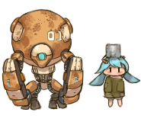

*Plot text:*

*Location, located in a municipal garbage dump*

A: Ah! A living human!

B: ‘living human’? You meaning...me?

A: Of course, I haven't seen other people for a long time! My name is Anatacia, and this is my best friend "Little Bear", what's your name?

B: Uh, my name is... emmm...Wait, have you always lived here? You are... well, how did you live till now? Don't you have your family?

A: Mr Bear is my family. Sometimes he will go out for a period of time, and then he will bring me a lot of delicious food. He will help me build blocks and tell me many things! (The robot makes a noise in agreement)

B: Well, that's really an amazing combination! Ah, right! (Takes out the photo) Have you and Mr Bear seen this man?

A: Hmm, no, but Mr Bear said that he had seen someone being chased by a group of "bad guys" before. Mr Bear drove those "bad guys" away. I don't know if it was him.

B: Really! ? Thank you, little sister, thank you! This is really a good news!

A: Are you leaving now, (hesitating) Uh, uh, if you still come back, you must come and play!

B: Certainly!

A: ...............Oh, bad! I forgot to ask her name!

1. **CG**

Text：

* 1. My father suddenly left me, leaving only a note-

"I am going to a place far away. If I didn't come back, don't come to find me..."

* 1. My intuition tells me that there must be something wrong. I found a map that shows that he has gone to Grey Hill?
  2. I rummaged through his stuff. He never let me do this before, but now he can't manage so much.

I found an envelope with a photo of him. In the photo, besides me and him, there was a woman whom I didn't know. What is going on, I never have a memory of my mother.

He seems to have participated in some terrible research. Since the end of the war, he seems to have become an alcoholic, and he doesn't talk much about his past. Is it because of these researches? I must find him...